SP21-BCS-035

talha islam

lab 1

**QUESTION #1,2,3**

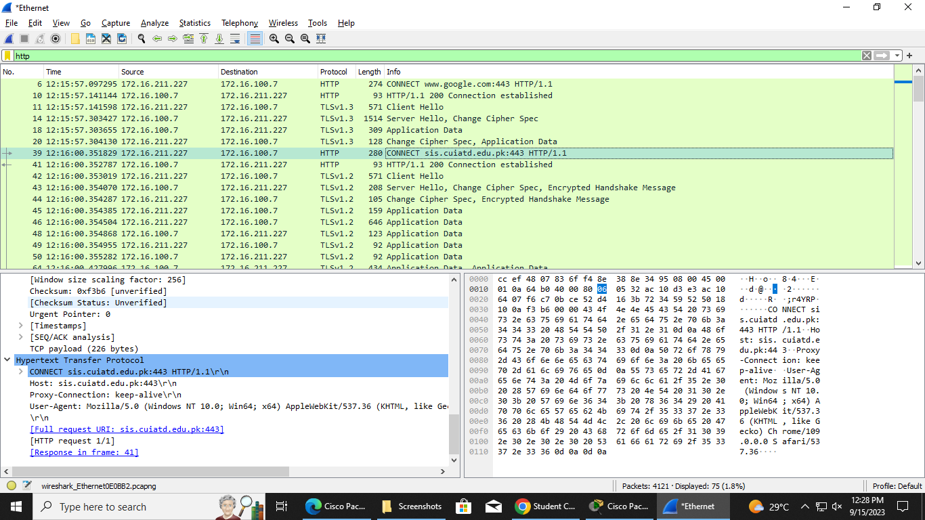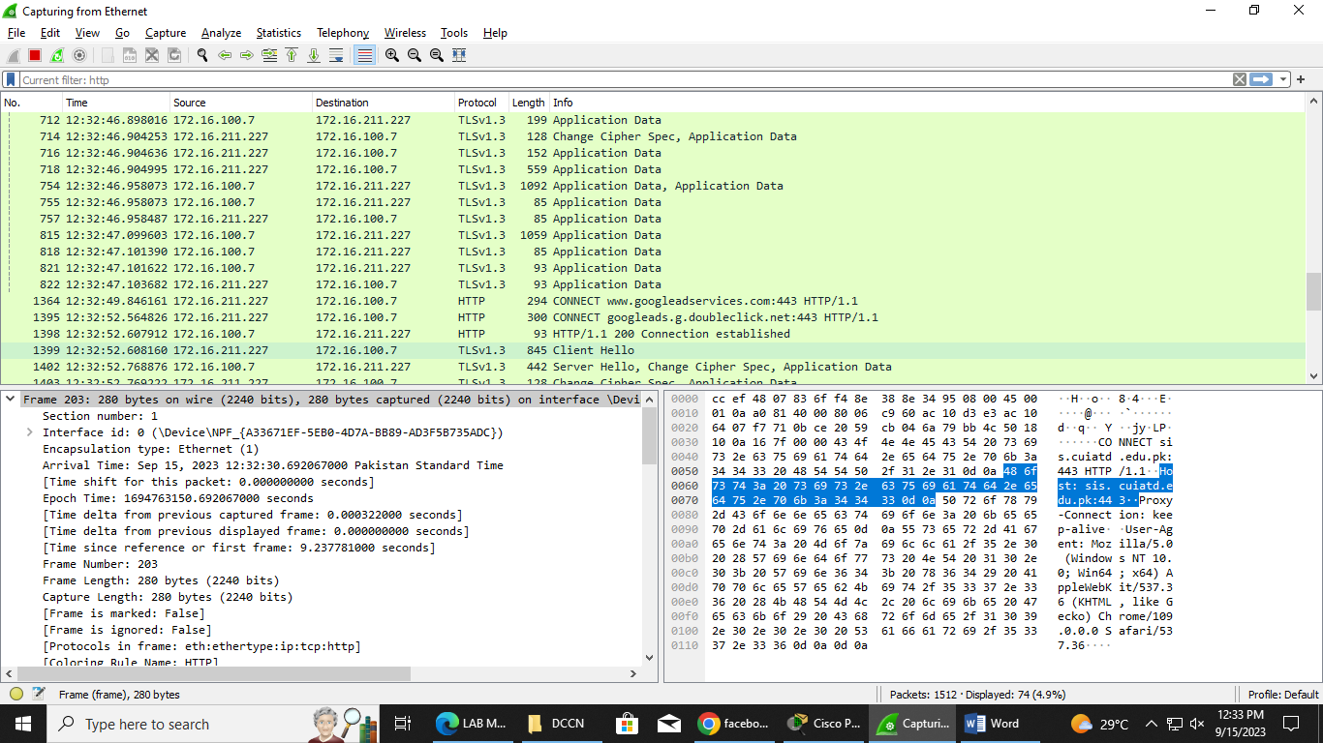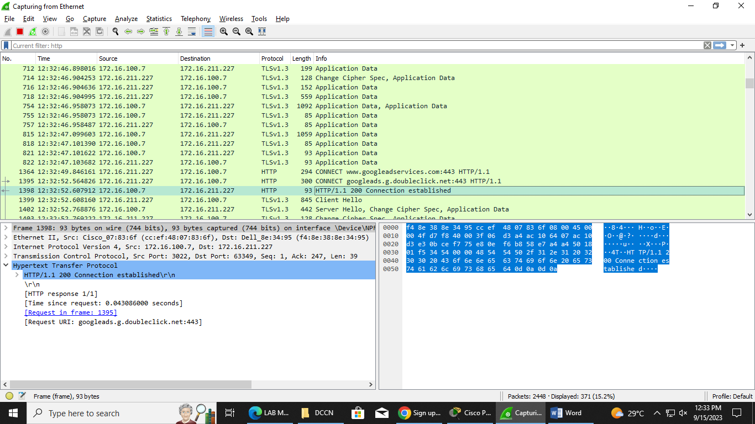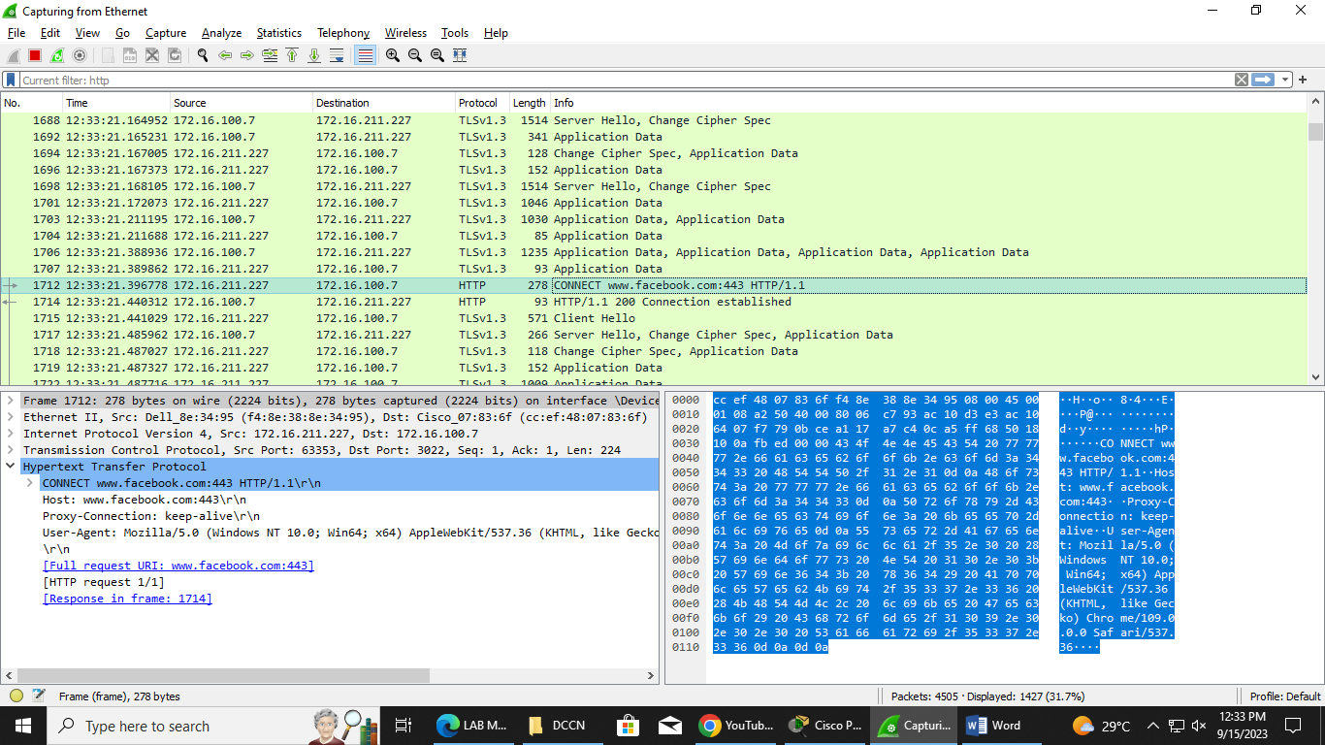

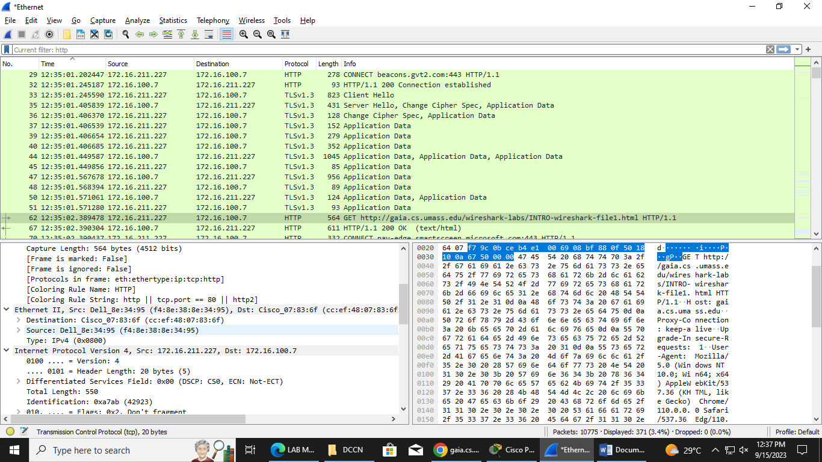

**Question #4**

C :\Users\SP21-B~2\A ppData\Local\Temp\wireshark_EthernetQ FJO B2.pcapng 10775 total packets, 371 shown No. Time Source Destination Protocol Length Info 62 12:35:02.389478 172.16.211.227 172.16.100.7 HTTP 564 GET http://gaia.cs.umass.edu/wireshark-labs/ INTRO-wireshark-file1.html HTTP/1.1 Frame 62: 564 bytes on wire (4512 bits), 564 bytes captured (4512 bits) on interface \Device\NPF_{A33671EF-5EB0-4D7A-BB89-AD3F5B735ADC}, id 0 Section number: 1 Interface id: 0 (\Device\NPF_{A33671EF-5EB0-4D7A-BB89-AD3F5B735ADC}) Encapsulation type: Ethernet (1) Arrival Time: Sep 15, 2023 12:35:02.389478000 Pakistan Standard Time [Time shift for this packet: 0.000000000 seconds] Epoch Time: 1694763302.389478000 seconds [Time delta from previous captured frame: 0.000129000 seconds] [Time delta from previous displayed frame: 0.818198000 seconds] [Time since reference or first frame: 4.660267000 seconds] Frame Number: 62 Frame Length: 564 bytes (4512 bits) Capture Length: 564 bytes (4512 bits) [Frame is marked: False] [Frame is ignored: False] [Protocols in frame: eth:ethertype:ip:tcp:http] [Coloring Rule Name: HTTP] [Coloring Rule String: http || tcp.port == 80 || http2] Ethernet II, Src: Dell_8e:34:95 (f4:8e:38:8e:34:95), Dst: Cisco_07:83:6f (cc:ef:48:07:83:6f) Destination: Cisco_07:83:6f (cc:ef:48:07:83:6f) Source: Dell_8e:34:95 (f4:8e:38:8e:34:95) Type: IPv4 (0x0800) Internet Protocol Version 4, Src: 172.16.211.227, Dst: 172.16.100.7 0100 .... = Version: 4 .... 0101 = Header Length: 20 bytes (5) Differentiated Services Field: 0x00 (DSCP: CS0, ECN: Not-ECT) Total Length: 550 Identification: 0xa7ab (42923) 010. .... = Flags: 0x2, Don't fragment ...0 0000 0000 0000 = Fragment Offset: 0 Time to Live: 128 Protocol: TCP (6) Header Checksum: 0xc11a [validation disabled] [Header checksum status: Unverified] Source Address: 172.16.211.227 Destination Address: 172.16.100.7 Transmission Control Protocol, Src Port: 63388, Dst Port: 3022, Seq: 1, Ack: 1, Len: 510 Source Port: 63388 Destination Port: 3022 [Stream index: 6] [Conversation completeness: Incomplete, DATA (15)] [TCP Segment Len: 510] Sequence Number: 1 (relative sequence number) Sequence Number (raw): 3034644585 [Next Sequence Number: 511 (relative sequence number)] Acknowledgment Number: 1 (relative ack number) Acknowledgment number (raw): 146769935 0101 .... = Header Length: 20 bytes (5) Flags: 0x018 (PSH, ACK) Window: 4106 [Calculated window size: 1051136] [Window size scaling factor: 256] Checksum: 0x6750 [unverified] [Checksum Status: Unverified] Urgent Pointer: 0 [Timestamps] [SEQ/ACK analysis] TCP payload (510 bytes) Hypertext Transfer Protocol